Adoption Application

Cat/Kitten’s Name:___________________ Today’s Date:___________

* Required
1. First name * Last Name *

**Have you ever adopted from us before? (circle) Yes No

2. Address * _______________________________________City/State___________________

3.Applicant Date of Birth * ____________________________

4.Primary Phone Number * Circle one: Home Work Cell Number: ________________

5. Alternate Phone Number Circle one: Home Work Cell Number:_________________

6. Email Address * _________________________________________________

7. Acceptable Contact Method (circle all that apply)

Text Phone Call Email Other (specify)__________________________________

8.If you are considering adopting a "special needs" pet, do you have experience with special needs animals? If so, please explain. *

9. Number of people in your household? * _____________________

10. Ages of children in the household (if any) * _____________________________________

11. Are all members of your household aware of and in agreement regarding a new pet?

____________________________________________________________________________

12. Do you own your home? * ________________________

13. If renting, please give the name and phone number of your landlord or Apartment Complex. *

14. Where will the pet be kept? * (circle one)

Inside only Mostly inside Mostly outside Outside only

15. If you circled mostly inside, mostly outside, or outside only, what type of shelter is outside? *

____________________________________________________________________________

16. Please list what pets you currently own, their age and species. *

____________________________________________________________________________

____________________________________________________________________________

17. Are they all spayed/neutered? * ______________________

18. How many pets have you owned in the past three years? * ____________________

19. Do you still have them? If not, what happened to them? *

20. If you have a dog or cat, what type of heartworm prevention are they on? *

19. If you have a dog or cat, have then received vaccinations within the past year? *
(circle one) Yes No

20. If you have a cat, have they tested negative for FIV & FeLV? *
(circle one) Yes No Unsure I do not have a cat.

21. If your pet has received vaccinations, who administered them? *

22. Please list any pets that will be residing with your pet but that you do not claim ownership of (example - roommate’s pets or pets of other family members). Please list the owner’s name and phone number.

____________________________________________________________________________

____________________________________________________________________________

23. If you are applying to adopt a cat, do you plan to have this cat declawed? *
(circle one) Yes No Unsure

24. If you have had pets, Please list the name and phone number of your veterinarian below. *
By submitting this form, you are giving us permission to ask your veterinarian questions regarding your previous/current pets' medical records.

If you have not had pets, still list the name and phone number of a veterinarian in your area you would like to use, or ask us for a recommendation!

25. How did you hear about us? *
Facebook PetFinder.com Adoptapet.com Our website Friend/Family

Other:

26. The average estimated cost of owning a dog or cat in the US is $800-$1000 for the first year and $500-$800 each year thereafter. Are you prepared to financially provide for the pet you are planning to adopt? *
(circle one) Yes No

27. You understand that you are applying to adopt a rescued cat whose previous medical history is unknown before it entered the rescue. You understand that we cannot guarantee the health of our animals. Kittens/cats are tested for FIV (Feline HIV) and FeLV (Feline Leukemia) before placement, but beyond that we cannot anticipate future medical problems that may arise. You agree that, as the kitten/cat's legal guardian, all future veterinary costs are your sole responsibility from the date of adoption.
(circle one) Yes No

28. What plan do you have in the event you are unable to care for your pet(s):

- When traveling away for extended periods of time?

____________________________________________________________________________

____________________________________________________________________________

____________________________________________________________________________

- Upon graduation or relocation?

____________________________________________________________________________

____________________________________________________________________________

____________________________________________________________________________

- If you become ill or are unable to care otherwise?

____________________________________________________________________________

____________________________________________________________________________

____________________________________________________________________________

Adoption Contract

Please initial next to each statement
I promise to be a responsible owner and provide adequate food, water, and veterinary care for the animal that I am adopting from FALC
I will never harm this or any other animal in my care. I will not allow others in my home to harm this animal or any other animal in my care.
I will never have my cat declawed.
If the animal goes missing, I will notify FALC immediately so that they can help with the search.
If I move, I promise that I will make every effort possible to take my new pet with me.
I will never abandon my new pet. If a circumstance arises in which I cannot keep my pet, I will notify FALC immediately.
If I decide that I can no longer care for this animal, I promise to return the animal to FALC.
If adopting a special needs animal, I understand that I am hereby responsible for the continued treatment and costs of treatment of this animal. I promise to provide all needed care for this animal.
Upon adoption, FALC is not responsible for any injuries to people, animals, or material goods that are caused by this animal. I accept responsibility for the animal that I am adopting and any behavior that the animal displays after adoption.
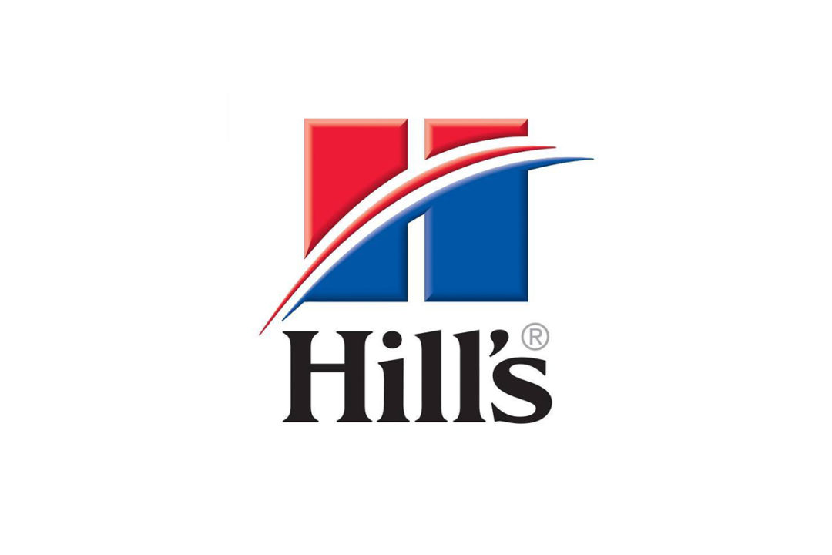
I consent to be subscribed as a Hill’s Pet Partner and receive coupons, adopter tips, and promotional information from Hill’s Science Diet. I can unsubscribe from emails at any time.

I understand that failure to perform the foregoing will constitute a breach of contract. In the event of any such breach of contract, I authorize FALC to reclaim possession of the adopted animal.

Adoption fees are refundable for seven days. If you wish to return your new pet after seven days, your adoption fee will not be refunded.

Adopter’s Signature: :

Date: :

STAFF ONLY:

Approval: _______________________ BOD Member________________________

BOD Signature:______________________________________________________________

